Template: Deliverable 4: Wireframes & Feature Plan

CSC425 Fall 2025

Student Name: Jahzara Broaster

Date Submitted: 21/09/2025

GitHub REPO URL: <https://github.com/MUS1C17/CSC425Team3.git>

Branch Name: d4-jahzara-broaster

1. Low-Fidelity Wireframes (Mobile-First)

Insert/export images of your sketches or digital mockups. Each wireframe should be clearly

labeled.

• Login Screen

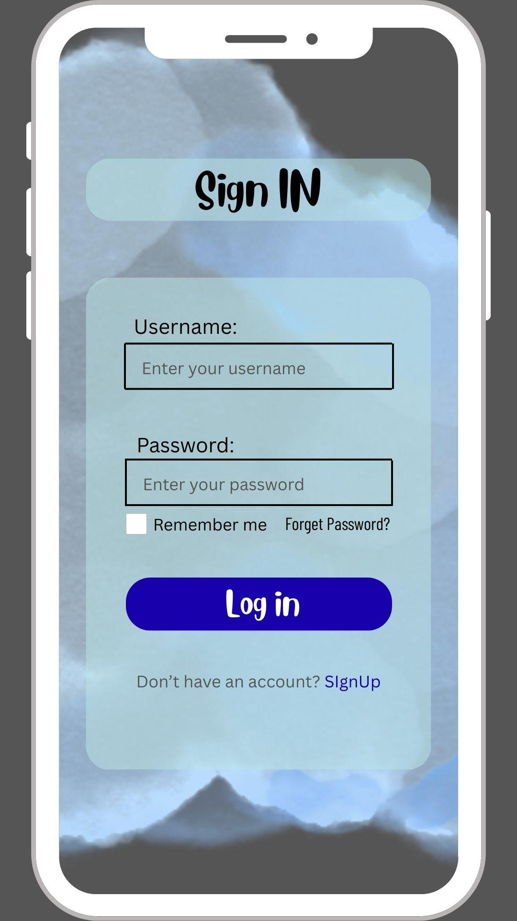

• Dashboard Screen

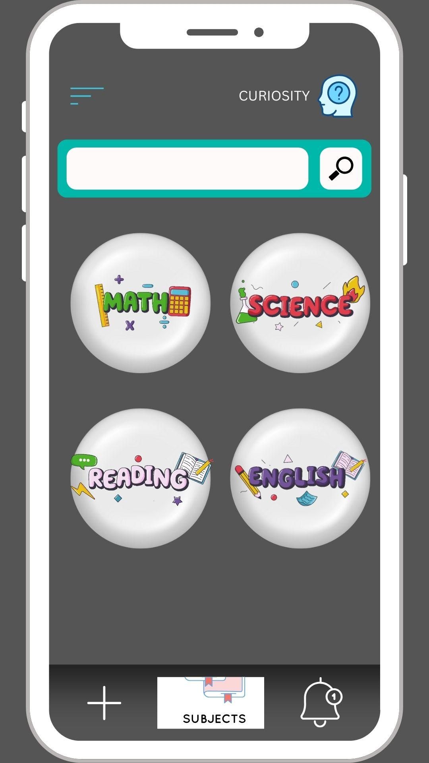

• Additional Major Screens (if applicable)

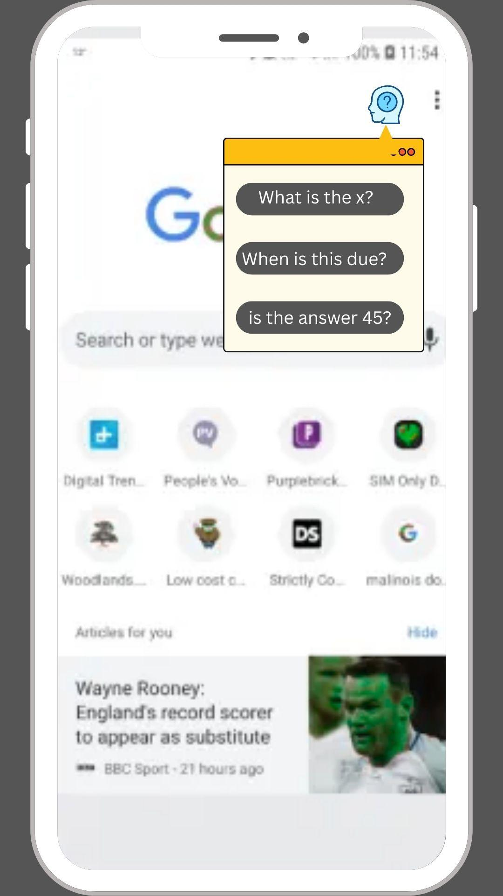

2. Functional Requirements

**User Authentication**

* Sign up, login, logout (including Google login support)
* Secure password handling and session management

**Class & Lecture Management (Teachers)**

* Create, update, delete classes and lectures
* Invite students via email to join classes
* Remove students from a classroom

**Comment & Discussion System (Students & Teachers)**

* Create → Students can submit comments/questions (anonymous or named)
* Read → Students and teachers can view all comments/questions after a lecture
* Update → Students can edit their own comments; teachers can update statuses (e.g., “addressed”)
* Delete → Students can delete their own comments; teachers can remove inappropriate content

**Collaboration & Interaction**

* Students can view and comment on other students’ posts
* Threaded replies for ongoing discussions after lectures

**UI/UX Personalization (All Users)**

* Toggle between light and dark mode
* Adjust text size for accessibility

**Navigation**

* Core flow: Login/Sign up → Dashboard → Classes → Lectures → Comments/Discussions

**Data Persistence & Backend Integration**

* Real-time sync (e.g., Supabase or Firebase) for comments, lectures, and class updates
* Persistent user preferences (theme, text size, anonymity settings)

**Instructor Dashboard (Teachers)**

* View all student activity in classes
* Filter, search, and sort comments/questions
* Export data for reports

**Error Handling & Input Validation**

* Invalid login attempts
* Empty comment submissions
* Duplicate comments or spam detection

**Notifications (Optional)**

* Students receive push/email notifications when their comment is replied to or highlighted
* Teachers notified when new students join or new comments are posted

3. User Stories

Provide 3–5 detailed user stories following the required format.

1. As a teacher, I want to create and delete classes AND lectures, so that I can manage the

content and structure of my courses.

1. As a student, I want to toggle between being anonymous or showing my name, so that I can

choose how I participate in discussions.

1. As a student, I want to see and respond to comments after the lecture is finished, so that

I can continue engaging with the material and classmates.

1. As a student, I want to delete or edit my comment, so that I can correct mistakes or

remove something I no longer want shared.

1. As a teacher, I want to remove and add students to/from a classroom, so that I can maintain

control over class membership.

4. User Journey Flow

**User opens app → Login screen**

* Default path: User enters credentials → redirected to **Dashboard**.
* Alternative path: User selects **Sign up** → creates account → redirected to **Dashboard**.

**Dashboard → Class Management**

* User taps the **plus icon** to add a new class.
* Newly created class appears on the **Dashboard**.

**Class → Lectures**

* User selects a class icon.
* User can either:
  + Enter a **class code** to join, or
  + Start a new **Lecture**.

**Lecture → Comments**

* User views lecture content.
* User can view and respond to **comments/discussions**.

**User Menu (three-line icon)**

* User can edit **profile information**.
* User can **log out**, ending the session.

**Notifications (bell icon)**

* Displays **unread comments/notifications**.
* Clicking opens recent updates for quick review.

(Optional Note)

This is my individual submission. The team will review all submissions and agree on a final

version for project continuation.

5. Document Layout Professional

Document must be organized, clean, professional, and ready for a developer to pick it up

and begin coding.

(Optional Note)

This is my individual submission. The team will review all submissions and agree on a final

version for project continuation